QUESTION BANK 2022-23

ENGLISH LANGUAGE (ENGLISH PAPER – 1)
STD. X
- (Do not spend more than 30 minutes on this question.) (20)
Write a composition (300-350 words) on any one of the following.

- Write a short story about a beggar who finds a fortune in a heap of rubbish.

- Narrate an incident which still fills your mind with fear. What lessons have you learnt from it?

- “We ourselves are responsible for our ill health in modern time.” Express your views for or against the statement.

- Describe some early morning sounds that you hear in your town.

v. Study the picture given below. Write a story or a description or an account of what it suggests you. Your composition may be about the subject of the picture or you may take suggestion from it; however, there must be a clear connection between the picture and your composition.
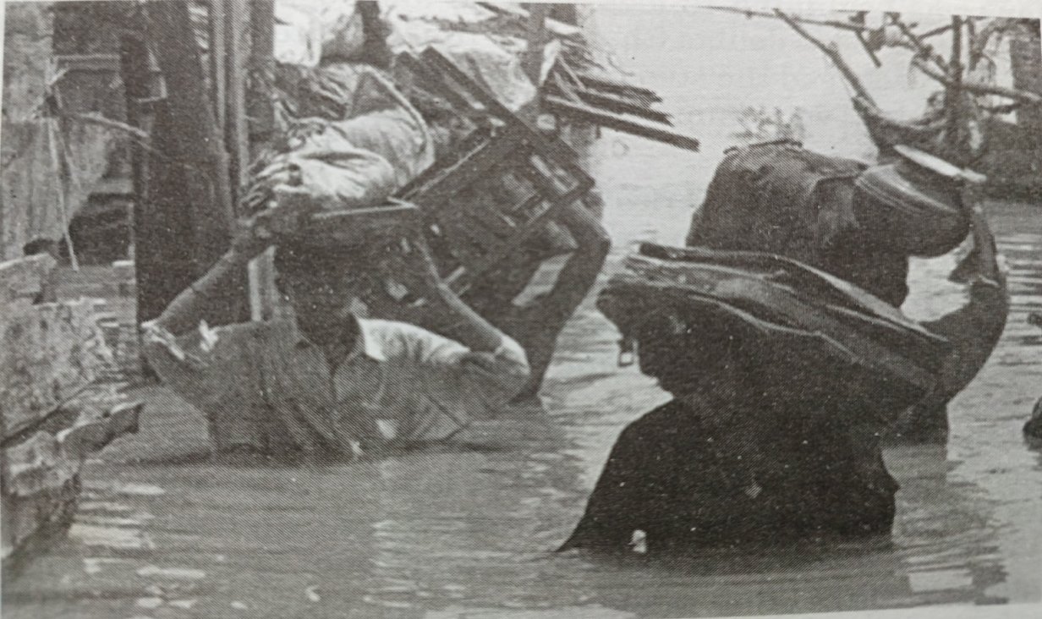

vi. Write an original short story which illustrates the truth of the statement, “One lie leads to another.”
vii. Write about an event when you are late for an important function. What lesson on punctuality did you learn?
viii. “School days are the happiest days of our lives.” Express your views either for or against this statement.
ix. Summers are becoming hotter with each passing years. Write a description of one such very hot day. What did you see and hear as you walked outside? How were birds and animals affected?
x. Study the picture given below. Write a story or a description or an account of what it suggests you. Your composition may be about the subject of the picture or you may take suggestion from it; however, there must be a clear connection between the picture and your composition.

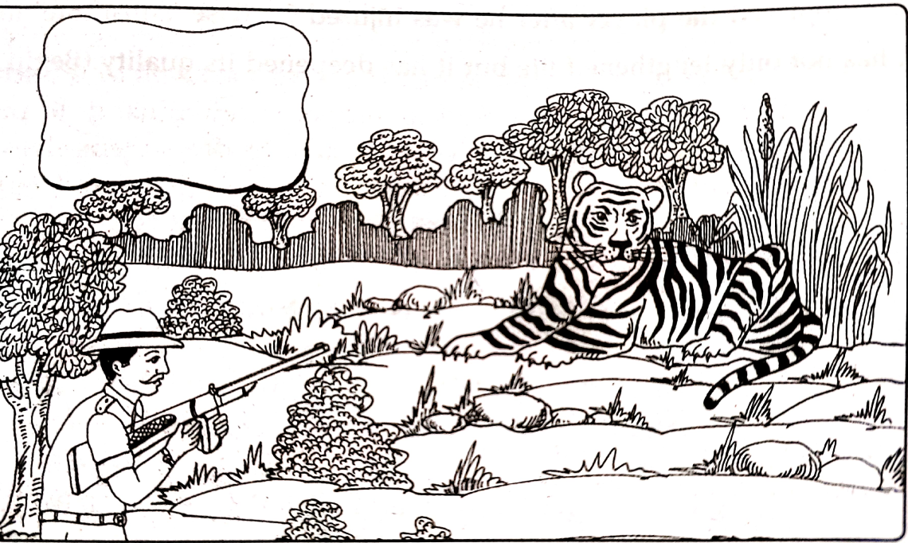

- (Do not spend more than 20 minutes on this question.)
Select any one of the following; (10)

- A heap of garbage has accumulated near your locality. The garbage removal truck of the Corporation has not come for a fortnight. This dump is not only an eye-sore but a health hazard as well. Write a letter to the Mayor of the local Municipality describing the inconvenience caused to the public and requesting him to get it removed quickly.
F = 3, C= 2, E= 5

- Write a letter to the editor daily news paper appealing for help for building a children’s hospital in your city.
(Format 3, Content 2, Expression 5)

- A friend of yours has been out of station for a month and there was an important event/function held in the school while he/she was away. Write him/her a letter describing the event/function, and your role in it.
(Format 2.5, Content 2.5, Expression 5)

- You have just bought a new camera of your choice with the pocket-money you had saved up over two years at a great sacrifice. Share your excitement with your friend, who is studying in another town. Give a clear description of your new possession, conveying your excitement.
F= 2 ½, C= 2 ½, E= 5

- (i) You are Secretary of the Fitness Enthusiasts’ Club of your school.
Draft a notice for the school notice board inviting students to participate in the programme of the International Yoga Day being organized in your school playground. (5)

(ii) Your school is hosting an interschool quiz competition. Write out a notice to be displayed in your school giving all details for the event. (5)

(iii) Write an e-mail to any famous yogacharya (yoga teacher) of your
city inviting him to be the guest of honour at the International
Yoga Day Celebration. Give him the details of the programme and
Request him to give useful tips to the young yoga enthusiasts. (5)

(iv) Write an e-mail to the Principal of a neighboring school requesting
him/her requesting to send a team of three members to participate in the quiz competition. (5)

- A. Read the passage carefully and answer the questions that follow;

The party began shortly after nine. Mr. Wood, who lived in the flat below, sighed to himself as he heard the first signs: the steady tramp of the feet on the stairs; the sound of the excited voices as guests greeted one another; and the noise of the gramophone, which was turned full on.
Luckily, Mr. Wood had brought some work home from the office, with which he occupied himself for a couple of hours, thus managing to ignore with some success the party which was going on over his head. But by eleven o’clock he felt tired and was ready to go to bed,through from his experience of previous parties he knew it was useless trying to go to sleep. He undressed and lay for a while non the bed, trying to read but the noise from above his head did not allow him to concentrate on what he was reading. He found himself reading the same page over and over again. He then switched off the light and buried his head in the pillow, in a desperate attempt to go to sleep. But even so he could not shut out the noise. Finally, after what seemed like hours, he switched on the light and looked at his watch : it was just after midnight.
But now his patience was quite exhausted. He leaped out of bed and putting on his dressing gown over his pyjamas, marched resolutely up the stairs to his neighbour’s flat. He rang the bell several times but the door remained shut in his face. This did not improve his temper. Just then one of the guests came out and went off down the stairs, leaving the door open. Mr. Wood went in. In spite of his odd dress, nobody took any notice of him. Then he caught sight of the owner of the flat and managed to attract his attention. The man whose name was Black, came across the room, smiling cheerfully, and before Mr. Wood could open his mouth to complain, said, “My dear fellow, come in and join us. I know our parties must bother you. I meant to send you an invitation.” Mr. Wood’s ill-temper vanished at once. “I’d better go and get properly dressed,” he said. As Mr. Wood left the room, Black turned to one of the guesats and said, “As soon as I set my eyes on him, I knew he had come to make trouble. That’s why I asked him to join us. Did you see how pleased he was? He went off at once to get changed. What a pity the party is nearly over!”
- Three words or phrases are given below. Give the meaning of each word as used in the passage. One word answer or short phrases will be accepted: (1X3=3)
- Ignore
- Disregard
- Achieve
- acknowledge
- Resolutely
- Half heartedly
- Determinedly
- cowardly
- Desperate
- Cheerful
- Composed
- Frantic
  - Disregard b. determinedly c. frantic
- How did Mr. Wood manage to ignore the party till he went to bed? (1)
Mr. Wood had brought some work home from office. This office work kept him occupied for a couple of hours and helped him to ignore.
- How long had the party been going on when Mr. Wood went to complain? (2)
The party has began shortly after nine and it was after midnight that Mr. Wood went to complain. The party had been going on for three hours.
- In what way was Mr. Wood’s dress odd? (2)
Mr. Wood was wearing a night gown over his pyjama. This was odd because the people at the party were suitably for the party and he stood out in sharp contrast to them.
- Why did Mr. Wood’s ill-temper suddenly vanish? (2)
Because the owner of the flat Mr. Black told him that he had meant to send him an invitation.
- Explain briefly the temperament and nature Mr. Black on the basis of his comments to one of his guests (2)
Mr. Black is a person who loves to have parties and his unmindful of the disturbance they cause to other people. He is also an extremely cunning fellow who knows how to deal with the situation most effectively and turn it in his favour.

- In not more than 50 words of your own, describe what Mr. Wood did from the time he leaped out of bed till he went back into his flat to change his clothes. (8)

B. Read the following passage carefully and answer the questions that follow;

I was never able to get over the feeling that plants and trees loved Grandfather with as much tenderness as he loved them. I was sitting beside him on the veranda steps one morning, when I noticed the tendril of a creeping vine that was trailing near my feet. As we sat there, in the soft sunshine of a north Indian winter, I saw that the tendril was moving very slowly away from me and towards Grandfather. Twenty minutes later it had crossed the veranda step and was touching Grandfather’s feet.
There is probably a scientific explanation for the plant’s behavior something to do with light and warmth – but I would like to think that it moved that way simply because it was fond of Grandfather. One felt like drawing close to him. Sometimes when I sat alone beneath a tree I would feel a little lonely or lost; but as soon as Grandfather joined me, the garden would become a happy place, the tree itself more friendly.
Grandfather had served many years in the Indian Forest Service, and so it was natural that he should know and understand and like trees. On his retirement from the Service, he had built a bungalow on the outskirts of Dehra, planting trees all around it: limes, mangoes, oranges and guavas; also eucalyptus, jacaranda and the Persian lilac. In the fertile Doon valley, plants and trees grew tall and strong.
There were other trees in the compound before the house was built, including an old peepul which had forced its way through the walls of an abandoned outhouse, knocking the bricks down with its vigorous growth. Peepul trees are great show-offs. Even when there is no breeze, their broad-chested, slim-waisted leaves will spin like tops, determined to attract your attention and invite you into the shade.
Grandmother had wanted the peepul tree cut down, but Grandfather had said, “Let it be. We can always build another outhouse.”
Our gardener, Govind, who was a Hindu, was pleased that we had allowed the tree to live. Peepul trees are sacred to Hindus, and some people believe that ghosts live in the branches of these trees.
“If we cut the tree down, wouldn’t the ghosts go away?” I asked.
“I don’t know,” said Grandfather. “Perhaps they’d come into the house.”
Govind wouldn’t walk under the tree at night. He said at once, when he was a youth, he had wandered beneath a peepul tree late at night, and that something heavy had fallen with a thud on his shoulders. Since then he had always walked with a slight stoop, he explained.
“Nonsense,” said Grandmother, who didn’t believe in ghosts. “He got his stoop from squatting on his haunches year after year, weeding with that tiny spade of his!”
I never saw any ghosts in our peepul tree. There are peepul trees all over India, and people sometimes leave offerings of milk and flower beneath them to keep the spirits happy. But since no one left any offerings under our tree, I expect the ghosts left in disgust, to look for peepul trees where there was both board and lodging.
Grandfather was about sixty, a lean active man who still rode his bicycle at great speed. He had stopped climbing trees a year previously, when he had got to the top of the jackfruit tree and had been unable to come down again. We had to fetch a ladder for him.
Grandfather bathed quite often but got back to his gardening clothes immediately after the bath. During meals, ladybirds or caterpillars would sometimes walk off his shirtsleeves and wander about on the tablecloth, and this always annoyed Grandmother.
She grumbled at Grandfather a lot, but he didn’t mind, because he knew she loved him.

- For each word given below choose the correct meaning (as used in the passage) from the options provided. (1X3=3)

- Tenderness:
- Affection
- Soreness
- Youthfulness

- Explanation:
- An excuse or pretext
- A statement or account that makes something clear
- A long-winded speech

- Vigorous:
- Strong, healthy, and full of energy
- Manipulating and meandering
- Timorous
i.1, ii. 2, iii. 1

- Why did the author feel that plants loved Grandfather with as much tenderness as he loved them? (2)
He saw the tendril of a creeping vine move very slowly towards grandfather and cross the verandah step to touch grandfather’s feet.
- Where had Grandfather worked for many years? (2)
The Indian Forest Service
- Which trees did Grandfather plant around his bungalow? (1)
Limes, mangoes, oranges, guavas, eucalyptus, jacaranda, the Persian lilac and a peepul tree.
- Why does the author say peepul trees are great show-offs? (2)
Because even when there is no breeze, their broad chested, slim-wested leaves will spin like tops, determined to attract your attention and invite you into the shade.
- How do we know Grandfather was fit? (2)
Because even at about sixty he was a lean active man who still rode his bicycle at great speed.
- What has the author said about the old peepul tree? Summarize the answer in 50 words. (8)

V. i. a. Fill in each of the numbered blanks with the correct form of the word given in brackets. Do not copy the passage but write in correct serial order the word or phrase appropriate to the blank space. (4)

Man has always (0)…made……(make) use of his inventive genius to force nature to yield its secrets. He has made spectacular break-throughs in technology firmly………..1……….(belief) that the sort of progress he ………2……..(make) is an unmixed blessing. He has seldom………..3………(give)thought to the fact that the air he………4……(breathe), the water he………..5……….(drink), or the food he………6……….(eat) could be……..7……….(exhaust). There is little realization on his part that what he………8…….(consider) progress is seriously disturbing the ecological balance of the earth.
- Believing 2. Is making 3. Given 4. Breathes 5. Drinks 6. Eats 7. Exhausted 8. Considers

b. Fill in each of the numbered blanks with the correct form of the word given in brackets. Do not copy the passage but write in correct serial order the word or phrase appropriate to the blank space. (4)

Years ago, the Clark family in Scotland had a dream. Clark and his wife worked and saved, making plan for their children and themselves……..1……….(travel) to the United States. It………2……..(take) years, but they had finally saved enough money and had got passports and reservations for the family on a new ship to the United States.
The family was filled with excitement at the thought of going to the US. However, seven days before their departure, the youngest son……..3……..(bit) by a dog. The doctor………..4……….(hang) a yellow sheet on the Clarks’ front door to warn people of the possibility of rabies. The Clarks…………5………..(quarantine) for fourteen days.
The family’s dreams ………..6……….(shatter). They could not make the trip to America as they……….7………(plan). The father shed tears of disappointment and cursed both his son and the dog for their misfortune.
Five days later, the tragic news spread throughout Scotland – the mighty Titanic in which the Clarks were to travel,………8………(sink), taking hundreds of lives with it.
- To travel 2. Took 3. Was bitten 4. Hung 5. Were quarantined 6. Were shattered 7. Had planned 8. Had sunk

ii. Fill in the blanks with appropriate words: (4)

1. The branches break __________ weight of the snow.
2. His sister has total authority ________ him.
3. I have run out ________ ideas.
4. The surgeon says the patient will pull _______.
5. The villagers protested ________ deforestation.
6. The thief made ________ with the lock car when no one was looking.
7. The strain was telling ______ his health.
8. Our living room looks very spacious after the connecting wall has been knocked.
1. under 2.over 3.of. 4.through 5.against 6. away 7. Upon 8. Down

- The municipality pulled……………the illegal construction along the roads.
- Don’t let your enthusiasm carry you…………… .
- He has embarked …………..a new project.
- During the President’s visit the entire area was cordoned…… .
- The truck crashed …………a tree.
- We have insured the car…………..theft.
- They conducted a search all ………….the premises.
16.She has decided to go in …………….medicine.
9.down 10. away 11. on 12. off 13. into 14. against 15. over 16. for

iii. Join the following sentences to make one complete sentence without using and, but or so. Choose the correct option. (4)

A. The woman’s house was burgled yesterday. I am sorry for her.
1. I am sorry that the woman’s house was burgled yesterday.
2. I am sorry for the woman whose house was burgled yesterday.
3. I am sorry for the woman’s house burgled yesterday.

B. They did not believe me. I had to give them evidence.
1. Although I gave them evidence, they did not believe me.
2. They did not believe me as well as my evidence.
3. I had to give them evidence to make ensure they might believe me.

C. I agreed to preside over the meeting. I am a nervous public-speaker.
1. I am a nervous pubic-speaker though I agreed to preside over the meeting.
2. If I am a nervous public-speaker, I shouldn’t agree to preside over any meeting.
3. I agreed to preside over the meeting though I am a nervous pubic-speaker.

D. I played the fool throughout the year. I failed miserably in every subject.
1. If I play the fool throughout the year, I am sure to fail miserably in every subject.
2. Since I failed miserably in every subject. I can play fool throughout the year.
3. Since I played fool throughout the year, I failed miserably in every subject
A. 2 B. 1 C.3 D.3

E. Sushil went home in time. His mother might blame him.

- Sushil went home before his mother could blame him.
- Sushil went home in time lest his mother will blame him.
- Sushil went home in time lest his mother should blame him.

- I have burrowed some money from Neha. I must return it to her.

- I must return Neha with her money I borrowed.
- I must return some of the money I had borrowed from Neha.
- I must return the money that I have borrowed from Neha.

- He will not do it. He will not allow others to do it.

- Neither will he do it nor allow others to do it.
- Neither did he do it nor did he allow others to do it.
- He will not allow others to do it neither he will do it.

- I often wake up late in the mornings. I am never late for school.

- Although I often wake up late in the mornings, I am never late for school.
- I am sometimes late for school because I often wake up late in the mornings.
- I am never late for school because I usually wake up on time.
  - 3 b. 3 c. 1 d. 1

iv. Rewrite the following sentences according to the instructions given after each. Make other changes that may be necessary, but do not change the meaning of the sentences. Choose the correct options. (8)

1. Anand said sadly, ‘How I wish I had been honest in my younger day!’
(Write in the indirect speech.)
(a). Anand said sadly that he was sad that he had been honest in his younger days.
(b). Anand exclaimed sadly that how he wished he had been honest in his younger days.
(c). Anand exclaimed sadly that he wished he had been honest in his younger days.

2. HIna is not the fastest runner in the school .
(End: …than Hina)
(a). Many runners are faster than Hina.
(b). In school many runners are not faster than Hina.
(c). Many other runners in the school are faster than Hina.

3. He is sorrowful, yet he is hopeful.
(Begin: Notwithstanding…)
(a). Notwithstanding he is sorrowful but he is hopeful.
(b). Notwithstanding his sorrow, he is hopeful.
(c). Notwithstanding hope he is sorrowful.

4. We cannot ask him for money in any condition.
(Begin: Under…)
(a). Under no condition can we ask him for money.
(b). Under no condition we ask him for money.
(c). Under what conditions we can ask him for money.

5. John did not get the job, though he had the necessary qualification.
(Begin: Despite….)
(a). Despite having the necessary qualification John did not get the job.
(b). Despite the necessary qualification John did not get the job.
(c). Despite having the qualification John did not get the job.

6. I had just entered the house when the phone bell rang.
(Begin: Hardly…)
(a). Hardly had the phone rung, when I entered the house.
(b). Hardly I entered the house, when the phone rang.
(c). Hardly had I entered the house, when the phone bell rang.

7. As soon as the bus stopped, I got off and started running.
(Begin: No sooner….)
(a). No sooner did the bus stop than I got off and started running.
(b). No sooner the bus stopped than I got off and started running.
(c). No sooner did the bus stop when I got off and started running.

8. They didn’t reach the station early and so they missed the train.
(Begin: Had they…).
(a). Had they been early they would have miss the train.
(b). Had they reached the station early they would miss the train.
(c). Had they reached the station early, they would not have missed the train.
1. c 2. a 3. b 4. a 5. a 6. c 7. a 8. C

9. The tornado had been raging for several hours before people were moved to safety. (Begin: The people………..)
a. The people were moved to safety before the tornado had been raging for several hours.
b. The people were moved to safety only while the tornado had been raging for several hours.
c. The people were moved to safety only after the tornado had been raging for several hours.

10. The contractor has carried out the repairs. (Begin: The repairs…………)

- The repairs has been carried out by the contractor.
- The repairs are completed by the contractor.
- The repairs have been carried out by the contractor.

11. “I will come as soon as I can.” Mother assured me. (Begin: Mother assured me……….)

- Mother assured me that she will come as soon as she can.
- Mother assured me to come as soon as she could.
- Mother assured me that she would come as soon as she could.

12. No one could open the door of the office. (Begin: The door of the office………….)

- The door of the office could be opened by no one.
- The door of the office could not be opened by no one.
- The door of the office could not be opened by anyone.

13. Walk carefully; otherwise you may slip and fall. (Use: lest)

- Walk carefully lest you should slip and fall.
- Walk carefully lest you may slip and fall.
- Walk carefully lest you will slip and fall.

14. He seldom gives me money. (Begin: Seldom………)
- Seldom does he give me money.
- Seldom he will give me money.
- Seldom he does give me some money.

15. My mother knows everything about my whereabouts. (Begin: There is…………..)

- There is everything my mother knows about my whereabouts.
- There is nothing my mother knows not about my whereabouts.
- There is nothing about my whereabouts which my mother does not know.

16.Some people claim that Hindi is the best Indian language. (Use the comparative degree of the adjective.)

- Some people claim that Hindi is better than any other Indian language.
- Some people claim that no other Indian language is as better as Hindi.
- Some people claim that Hindi is the better of all Indian languages.

- a 2. c 3. c 4. c 5. a 6. a 7. c 8. a

*********************

